
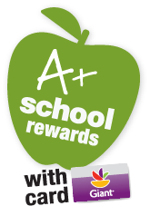

Dear Tyler Parents:

Welcome to the start of a new school year and another year of A+ School Rewards. Starting October 8, 2010 through March 25, 2011 Tyler Elementary School will have the opportunity to earn cash through Giant A+ School Rewards Program.

All you have to do is:
Log on to www.giantfood.com/aplus to register online
OR
Dial 1-877-275-2758 to register your card over the phone

After you register your card, each shopping trip at Giant using your GIANT Card earns CASH for our school! Each month, the amount of CASH awarded will be updated on the Giant website. You can track the amount of points you earn for our school by checking your grocery receipt and online when you create an account at giantfood.com. Our school will receive a check at the end of the program. The money can be used for any of our school’s educational needs.

Remember, even if you registered your card last year, you must re-register this year for our school to receive credit. Attending to this simple process makes a HUGE difference to our school. We need your support. Please be sure to register your card to benefit Tyler Elementary School using ID #01941
Tyler Elementary School

Also, don’t forget to encourage your friends and relatives to do the same. It could mean the world to our children.

